HISTORIC HOME TOUR RETURNS ON OCTOBER 8TH

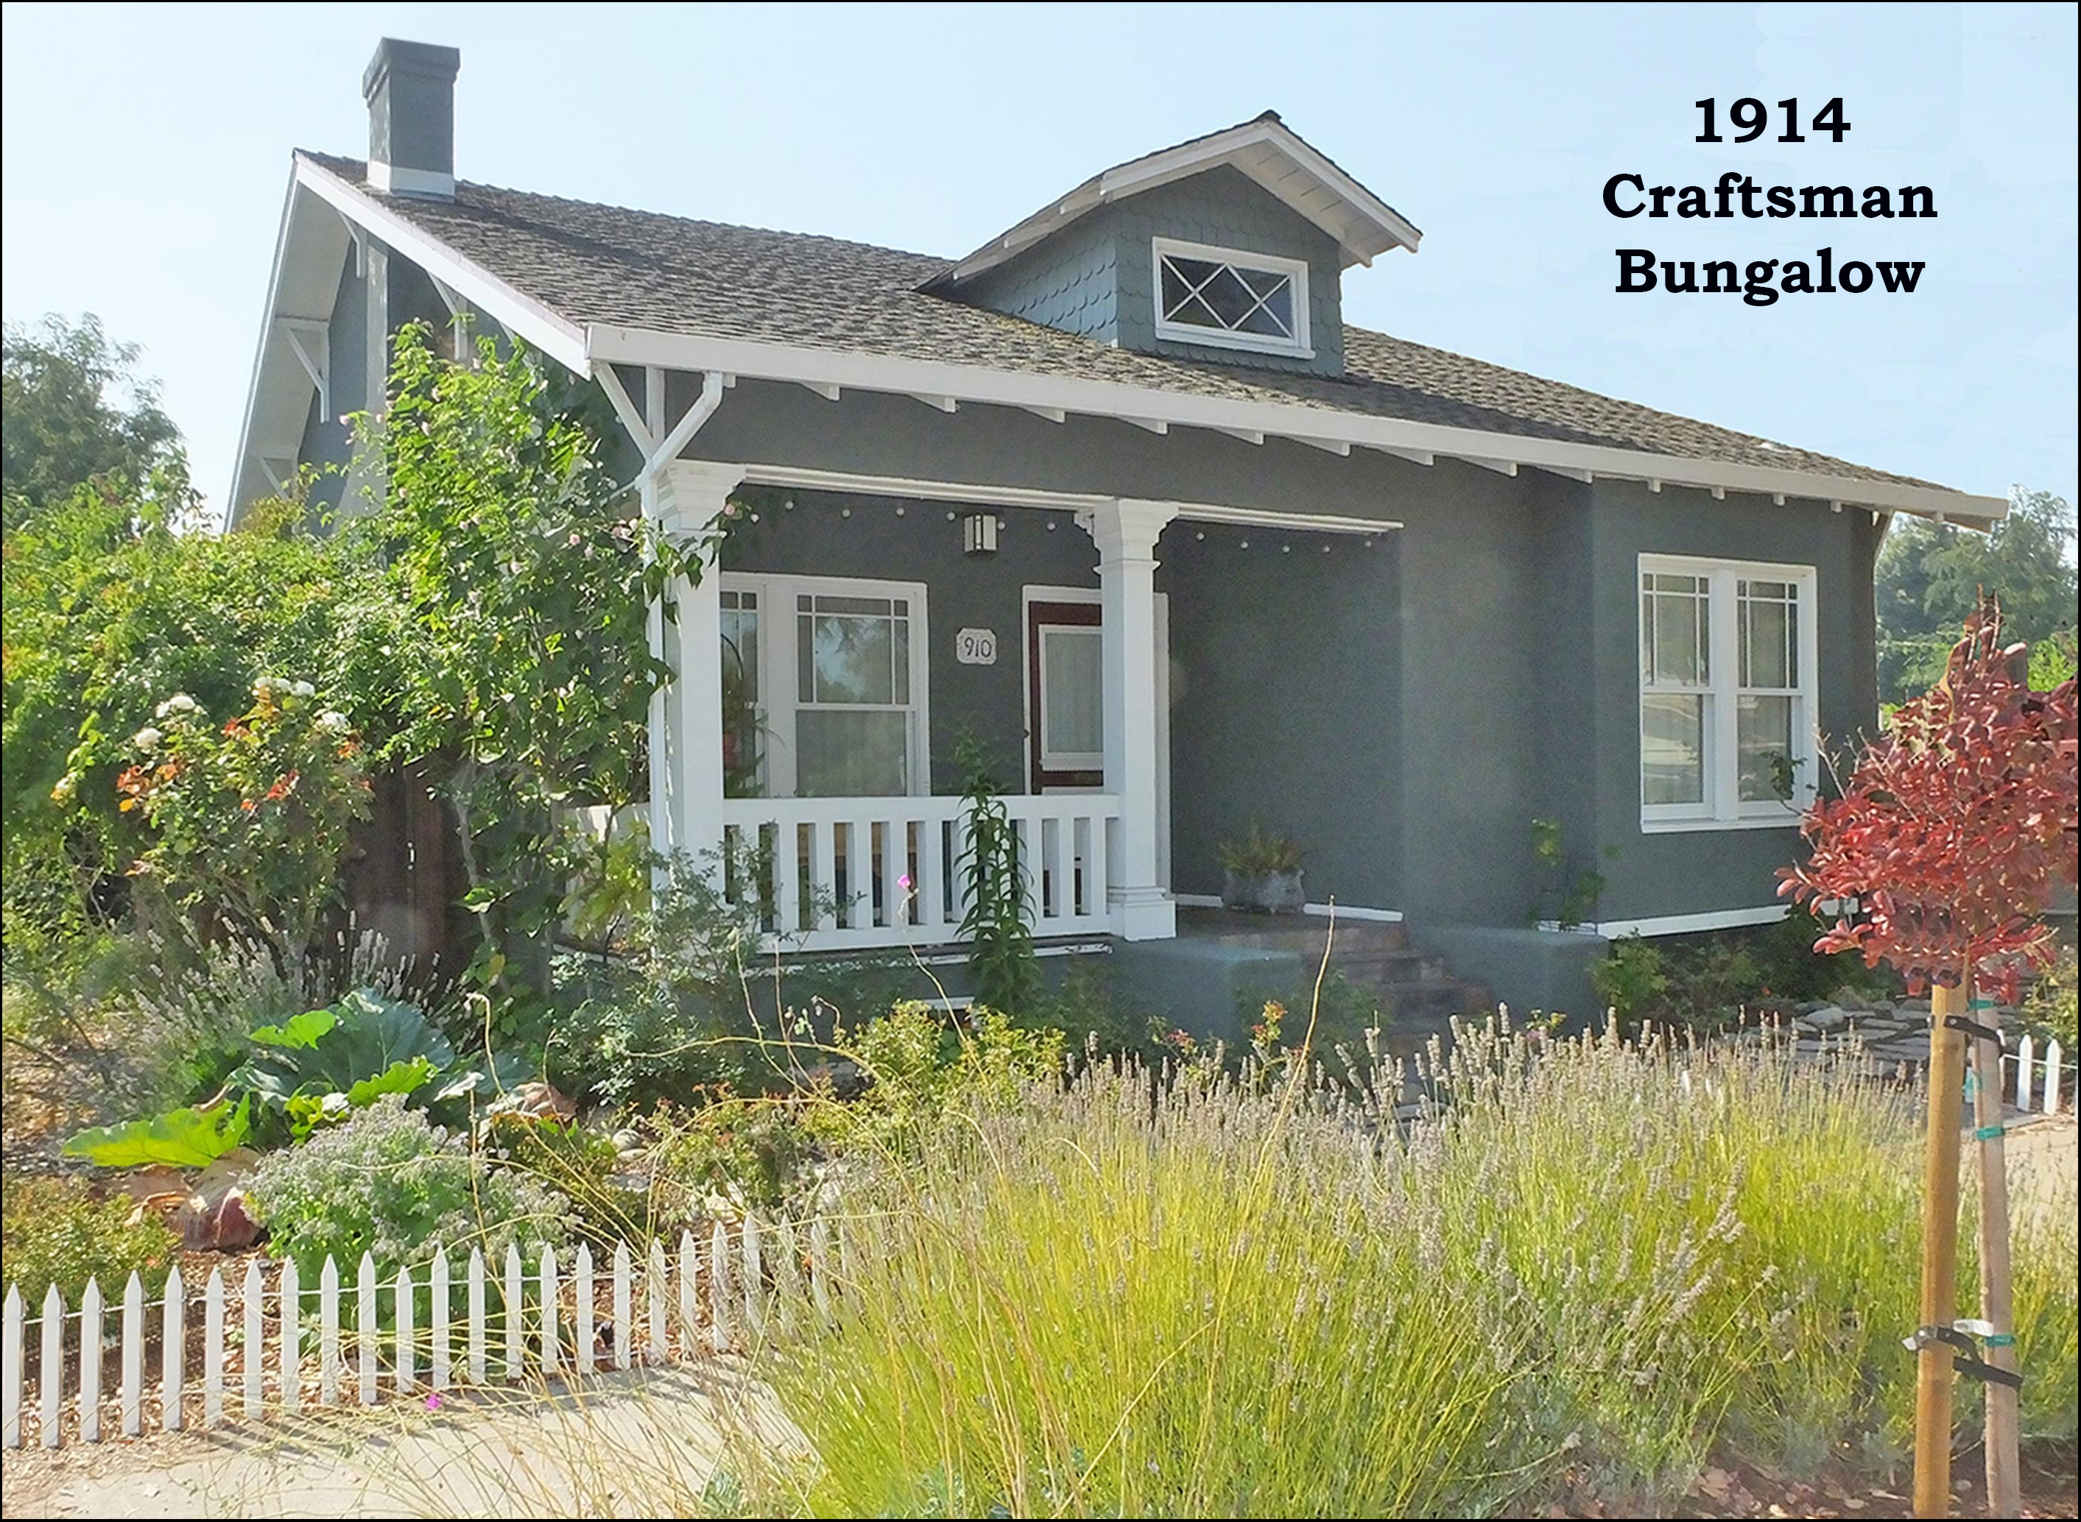
This restored 1914 Craftsman bungalow will be one of the many homes
on this year’s Historic Home Tour in Martinez.

The Martinez Historical Society will host its 10TH annual Historic Home Tour on Saturday October 8th.

The charming home pictured above is but a sample of the houses that you will see on the Tour. This particular house is a Craftsman bungalow built in 1914. It was acquired by its present owner in 2001. He then set about restoring his home – taking it back as much as possible to what it may have looked like 102 years ago. The carpets were removed and the hardwood floors refinished. Period-correct windows were installed. And many other restoration projects were undertaken in the house.

After the work on the home was completed, antique furniture was placed in the rooms and paintings by the wife’s artist-grandmother were hung on the walls. And the many other touches were added that turn a house into a home.

You’ll find that many of the houses on the Home Tour have interesting features which reflect the interests and personalities of the owners. For this house, it’s a model train that begins chugging around the living room (at the level of the picture rails) as one enters the front door.

The 2016 Home Tour will begin at the Shell Clubhouse. Buses with tour guides will run every 10 minutes to shuttle you to the homes and the museums on the Tour. There will be docents in each home to point out notable features of the house. While on the Tour, you will also see interesting demonstrations, displays and exhibits. And live musicians will entertain you at several locations. More information about the Tour can be found at the website: www.MartinezHomeTour.com

Calendar Details:

Date: Saturday, October 8th.
Time: 10 am to 4 pm. Start at any time, but allow 2+ hours for the Tour.
Location: Begin at the Shell Clubhouse, 1635 Pacheco Blvd. in Martinez.
Tickets: $25 from Eventbrite or select Merchants in Martinez. $30 at the gate.

The Martinez Historical Society would also like to thank its corporate sponsors whose contributions and support make our wonderful Tour in Martinez possible:

• Shell Martinez Refinery  • West Berkeley Design Loop  • Republic Services (Allied Waste)  • Shell Western States Federal Credit Union  • Les Schwab Tires of Martinez  • Ecomulch  • Schroder Insurance Services  • Leading Edge Pest Management | • Cole Real Estate  • City of Martinez  • Community Focus  • Shell Chemical Company  • Hagin’s Automotive  • Bisio / Dunivan  • Connolly & Taylor Chapel  • Michael Briones, J.Rockcliff Realtors

Note to editor:
- There is more info about the Tour on the website: www.MartinezHomeTour.com
- You may also contact:
  - Carolyn Duncan (Chair) at (925) 864-8457
  - John Curtis (Webmaster) at curtisjd@ix.netcom.com

