EXAMPLE

2015 FACEBOOK POST THANKING SPONSORS

----

POSTED ON A REGULAR BASIS IN SUMMER AND FALL

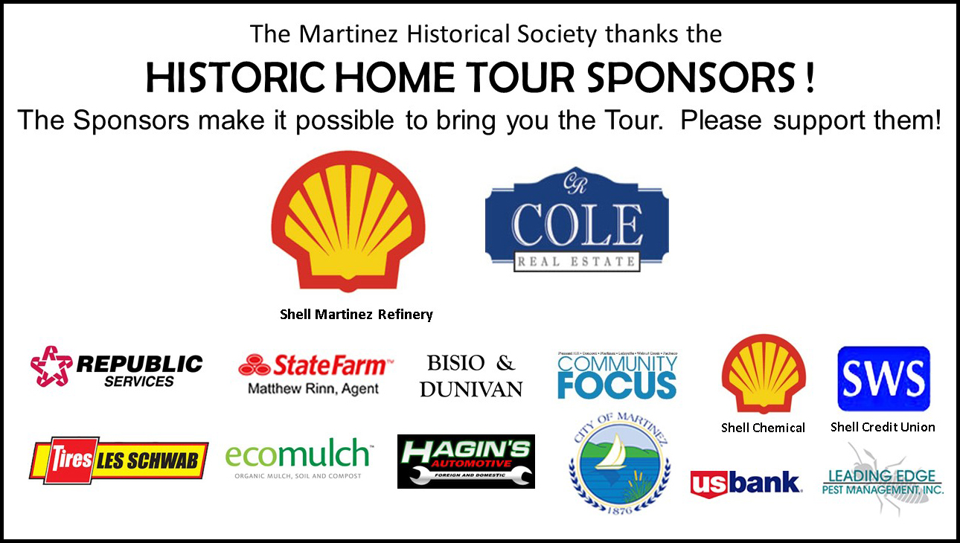

|  |  |
| --- | --- |
| Main Facebook page: | [www.facebook.com/MartinezHistoricalSociety/](http://www.facebook.com/MartinezHistoricalSociety/) |
|  |  |
| Lesser pages: | [www.facebook.com/MartinezMuseum/](http://www.facebook.com/MartinezMuseum/) |
|  | [www.facebook.com/groups/262312649079](http://www.facebook.com/groups/262312649079) |
|  |  |