PRESS RELEASE

Martinez Historical Society
PO Box 14 (1005 Escobar Street)
Martinez, California

Date: August 9, 2014

Contacts: Carolyn Boone
Email: cfboone@aol.com
Telephone: (925) 864-8457

Janie Mori
Email: morijane@yahoo.com
Telephone: (925) 228-0158

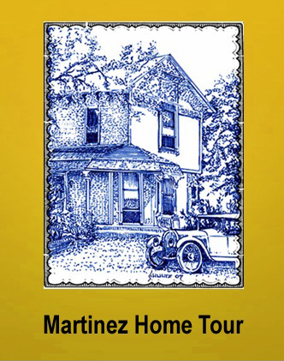

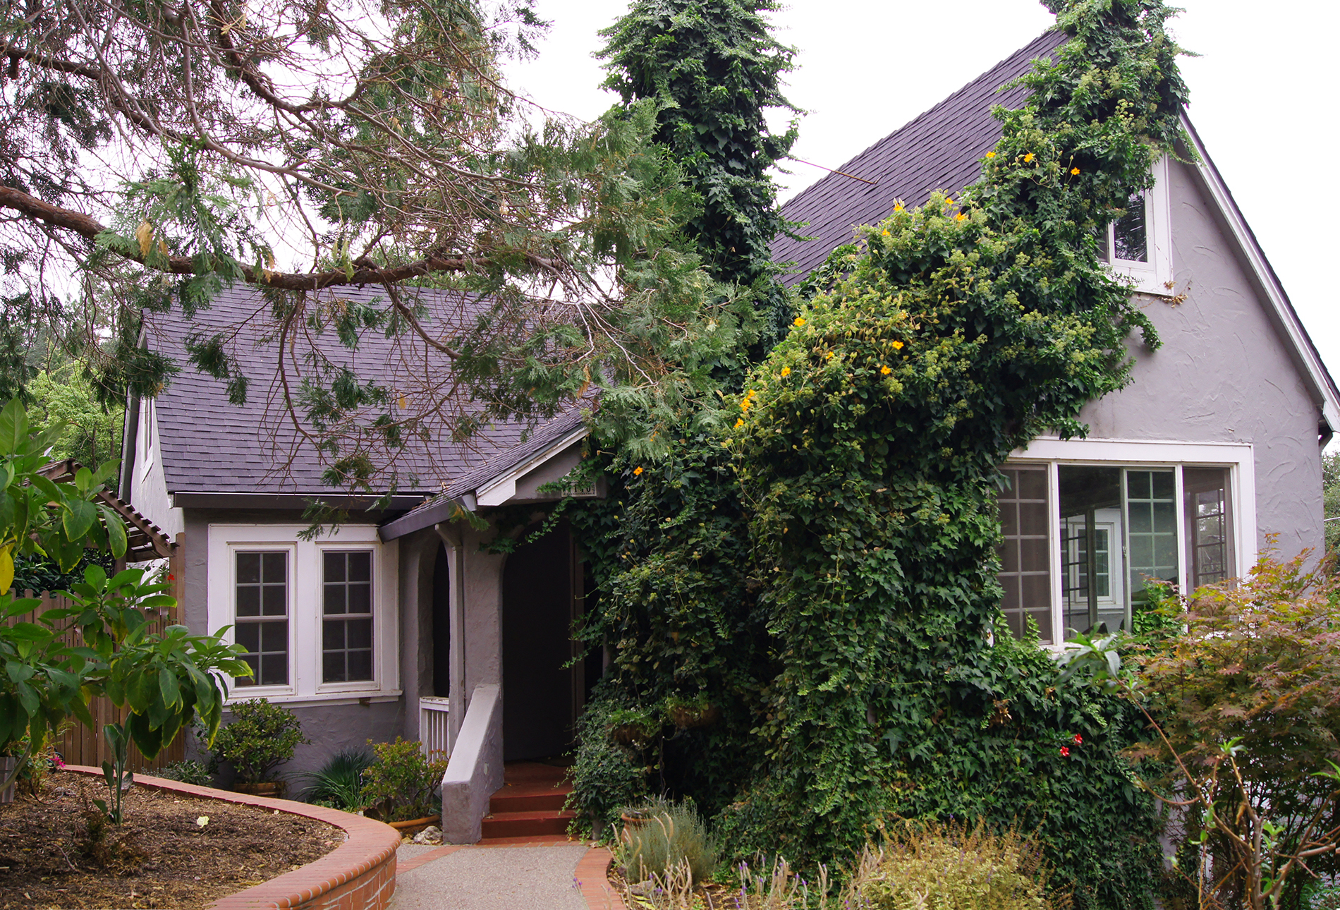
This charming vine-covered residence will be on the Historic Home Tour.
It is an example of the English Cottage style homes popular from 1910 to 1940.

Martinez Historical Society Home Tour
Saturday, October 11, 2104

MARTINEZ – When you drive down Alhambra Avenue, do you marvel at how well kept the older homes lining the street are? Have you ever walked your dog in the neighborhood of Green Street and Arlington Way and wondered what the interior of any one of the homes was like? Do you enjoy home decorating and gardening? If you answered “yes” to any of these questions, the Martinez Historical Society Home Tour 2014 is an event you should not miss.

Over 400 people who attended last year’s Home Tour not only learned about the history of Martinez, but were amazed at the gardens and interiors of six (6) private homes representing several architectural styles of the early 20th century.

The visitors admired the vintage features of the older homes such as dramatic columns, paneled walls and sumptuous crown molding. Tour goers were also intrigued by the newer additions to the homes that blended in so well with the old: features ranging from newly built-in Craftsmen bookshelves to a Murphy bed concealed in the wall cabinets of a guest cottage.

This year’s tour on Saturday, October 11th promises to be just as exciting with six (6) homes new to the tour. This year features a restored Craftsman home so noteworthy that it was featured in the Winter 2013 issue of American Bungalow. An added feature this year will be a tour of the historic 1930 Masonic Temple.

This year’s homes are clustered in the Arlington Way neighborhood of Martinez. It is hard to imagine today, but between the years of 1905 and 1914, the area of Green Street, Talbert Street and Arlington Way was called the Bay Area Pavilion. The Pavilion was an area where various forms of entertainment were located for the residents of both Martinez and outlying towns. Today the area is filled with some of the town’s most charming examples of vintage homes, almost all built before World War II.

Like the homes on past tours, there will be vintage features to admire such as built-in china cabinets and sideboards. Tour goers will also be intrigued by newer additions to the homes that blend in so well with the old: features ranging from reproduction push-button light switches to newly fabricated leaded glass cabinets.

The homes on the tour also feature attractive gardens, and some have impressive outdoor entertainment areas too. Last year, the 1930 English Cottage house on Ulfinian Way had both a vegetable garden and a beehive which has already produced two crops of honey that year. The 1918 Craftsman house on Court Street had a 3-level deck between the main house and the guest cottage. “This is stunning,” said Sabine Pitts. “They have created magic in this back yard.” Sabine is a good judge of gardens. The flower-filled garden in front of her own Craftsman house on the 1400 block of Alhambra Avenue has been attracting attention for years.

The use of color in the homes was another noteworthy feature of the 2013 Tour. In the 1905 Folk Victorian on Warren Street belonging to Craig and Shelly Thompson, there were trompe l’oeil swags and tassels painted on the dining room walls which seemed 3-dimensional at first glance. In the Costanza House, the entire ceiling of the sunset room was a hand-painted mural of the sky over San Francisco Bay at dusk with the Golden Gate Bridge in the background. Tom and Reeny Dorscher used color in a more conventional manner in their Craftsman house on Court Street. “Reeny’s use of color is extraordinary,” said Georgia Stockton, a retired social worker. “She picked up colors from the 1930s and 40’s textile patterns in the house and used them on walls, furniture and accent pieces. It’s all so colorful and it works so well together.” Georgia was one of the volunteer docents in the homes during the Tour.

One of the best features of the Home Tour is the opportunity to meet some of the home owners who personally speak to visitors, answer questions, and talk about their experiences in renovating and furnishing their older homes.

“I never had so much fun in my life,” said homeowner Robert Schultz last year. “I really enjoyed entertaining all our visitors today.”

When asked why she wanted to be part of a Home Tour, homeowner Reeny Dorsher smiled and replied: “I love my house and I would love to have other people see it.”

In fact, some homeowners from past years had such a great experience during the Tour that they joined the Home Tour Committee and are now working to plan this year’s event. There are still more opportunities to volunteer for this year’s tour on the day of the event -- as docents and ticket takers. To volunteer, contact the Historical Society through its website: www.MartinezHomeTour.com.

The date for this year’s Tour will be Saturday, October 11, 2014. That is the day to discover the treasures that make Martinez more than just another small town.

Tickets are $25 in advance and $30 at the door. They can be purchased at www.Eventbrite.com (via credit card) or from the following merchants for cash or check after September 1st:

I’ve Been Framed (411 Ferry Street)
Char’s Flowers (635 Main Street)
Martinez Museum (Court & Escobar Street)
Mountain Grounds (Alhambra & J Street)
Rumain’s Jewelry (510 Center Avenue)
Bagel Street Café (580 Center Avenue)
The UPS Store (the Lucky Shopping Center).

The sponsors who make the Tour possible are as follows:

Shell Martinez Refinery
Cole Real Estate
Shell Chemical Company
Republic Services
Shell Western States Federal Credit Union
U.S. Bank
Hagin’s Automotive
Bisio / Dunivan
Dolan’s Lumber, Doors & Windows
Best Western Plus John Muir Inn
State Farm Insurance, Matthew Rinn, Agent
Les Schwab
EcoMulch
City of Martinez

Note to the Press: The Society will be submitting additional press releases to your office between now and October 11th. The photos of the other homes on the Tour are reserved for illustrating those releases.

