PRESS RELEASE

Martinez Historical Society

PO Box 14 (1005 Escobar Street)

Martinez, California

August 15, 2013

Contacts:

Carolyn Boone Duncan, Chair

Email: [cfboone@aol.com](mailto:cfboone@aol.com)

Telephone: (925) 864-8457

Janie Mori, Media Relations

Email: [morijane@yahoo.com](mailto:morijane@yahoo.com)

Telephone: (925) 228-0158

John D. Curtis, President

Email: [CurtisJD@ix.netcom.com](mailto:CurtisJD@ix.netcom.com)

Telephone: (925) 957-1000

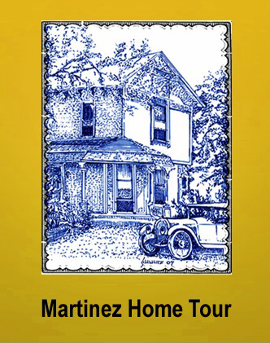

MARTINEZ – The Martinez Historical Society and its volunteers have been commended by the Conference of California Historical Societies (CCHS) on the excellence of their [Historic Home Tour](http://www.martinezhometour.com) website. “It’s the best home tour website that we have yet seen,” said Ben Wirick, the CCHS Administrator. “It does an excellent job of portraying the home tour experience. We encourage other historical societies throughout California to look to Martinez as a model for setting up their own home tour websites.”

[CCHS](http://www.californiahistorian.com/index.html) is a state-wide federation of local historical societies and other institutions such as museums, libraries and other history-oriented groups. Established in 1954, CCHS helps its 500+ [members](http://www.californiahistorian.com/membership-info.html) connect and share history. It also helps museums develop skills in management, acquisition, preservation, and restoration techniques. In addition, CCHS is the publisher of [*California Historian*](http://www.californiahistorian.com/magazine.html) magazine.

The Martinez Historical Society organized its first historic home tour in 2007. It has since become an annual event held on the 2nd Saturday in October of each year. On each tour, the Society opens up 6 or 7 private homes with historic or architectural merit to the public. “Unless one knows the owner, this is a once-in-a-lifetime opportunity to see the interior of the house,” said Home Tour Chair, Carolyn Boone Duncan. “The tours are also a great way for visitors to develop an appreciation for our town’s historic and architectural heritage – and the website is the vehicle for doing the same on the worldwide web.”

Martinez was a Gold Rush town established in 1849 and was long the commercial center for the County. It therefore has the largest collection of historic homes in the area. One of these homes belongs to Sabine Pitts, whose 1925 Craftsman house on Alhambra Avenue is well known to Martinez residents because of the luscious year round garden surrounding it “I loved having my house on the Tour last year. Showing my beloved home and garden was very rewarding.” She added: “I met some of the nicest people during the Tour.”

“~~It’s a~~ The website that we use to promote the Tour is a visually rich medium,” said Janie Mori, the Media Relations Coordinator for the Home Tour. “The gorgeous photos you will see on the site were taken by our photographer, Carter Wilson, who does wonderful work. The website is a great help to me in promoting the Tour, though we still do the usual press releases and we still promote the Tour using other traditional methods.”

It takes the efforts of up to 100 volunteers to put on the Home Tour each year. “We’re looking for one more [volunteer](http://www.martinezhometour.com/index-5C.html) to take over the webmaster’s duties,” said John Curtis, the Society’s president. “Until then, I take care of the website myself as time permits. Over the course of the last year, I finished uploading the photos of the [2012](http://www.martinezhometour.com/index-11C.html), [2011](http://www.martinezhometour.com/index-4C.html) and [2010](http://www.martinezhometour.com/index-8C.html) tours to the website. Last weekend, I uploaded the photos for the [2009](http://www.martinezhometour.com/index-15C.html) tour.”

This year’s Home Tour will take place on Saturday October 12th. Details will be forthcoming over the next 2 months. Tickets are now on sale at the tour [website](http://www.martinezhometour.com/index-2C.html) (credit card purchases) and will soon be available at selected [Martinez merchants](http://www.martinezhometour.com/index-9C.html) (check and cash purchases). Tickets are $30 ($25 if purchased in advance). Please support the Home Tour [sponsors](http://www.martinezhometour.com/index-3C.html) who help the Society hold down ticket prices. Gold sponsors are:

* Shell Martinez Refinery
* S and S Supplies & Solutions
* Cole Real Estate

And the bronze sponsors are:

* Allied Waste
* Shell Chemical
* Shell Western States Federal Credit Union
* Hagin’s Automotive
* Remodel Me
* Wendt Heating and Air
* Dolan’s Lumber, Doors and Windows
* Bay Alarm
* State Farm Insurance (Mark Woodard, Agent)
* City of Martinez

Sample photos are included below. More photos are available at the [website](http://www.martinezhometour.com/index-11C.html). Contact Janie Mori at [morijane@yahoo.com](mailto:morijane@yahoo.com%3cmorijane@yahoo.com) for additional information.

Date: August 15, 2013

File: MHS – Home Tour 2013 – Press Release 2.doc

1935 Tudor Revival Home on Pine Street

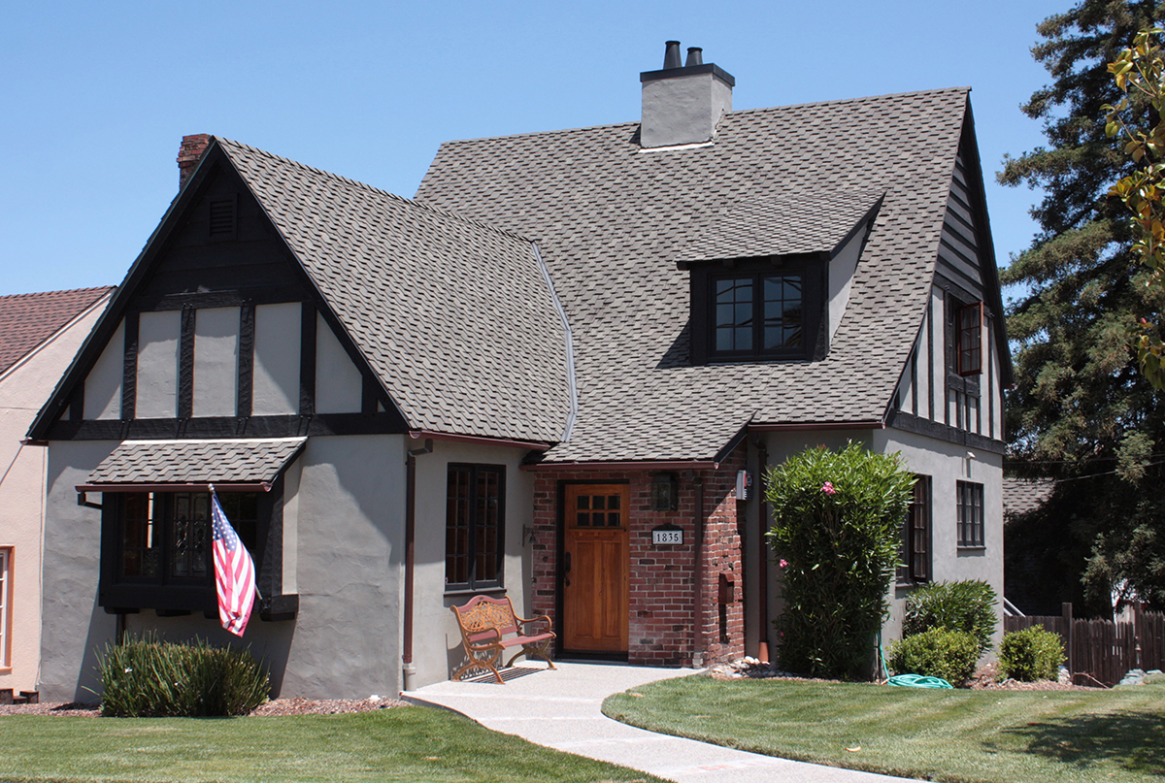

1935 Tudor Revival Home on Pine Street – Interior (same house as above)

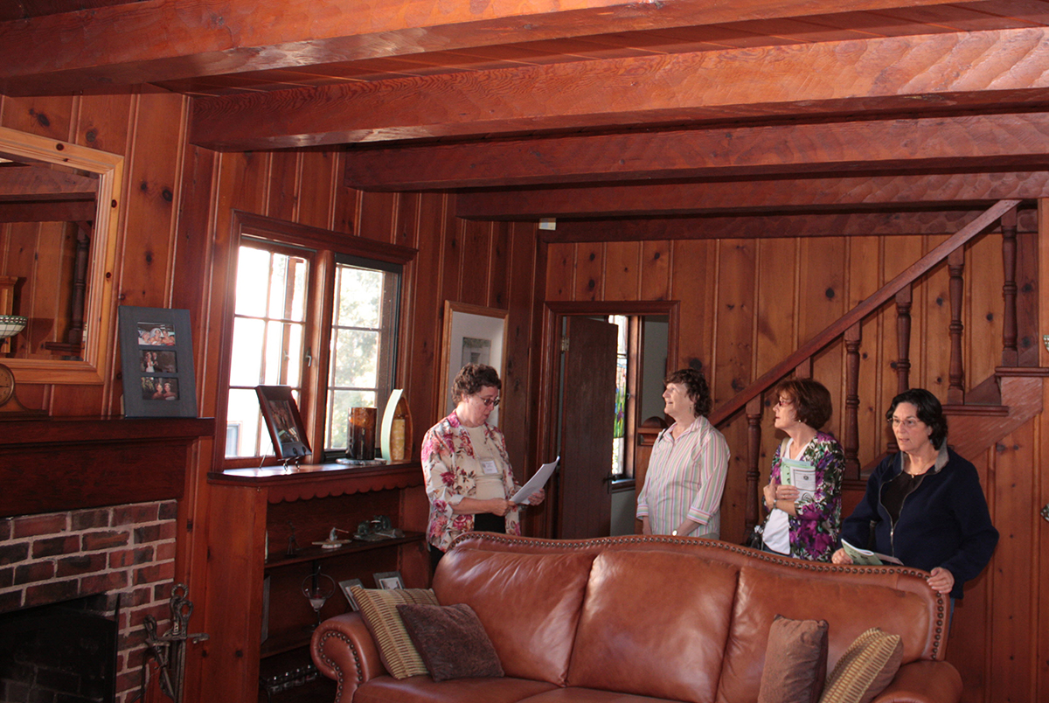

1870’s Victorian on Alhambra Avenue

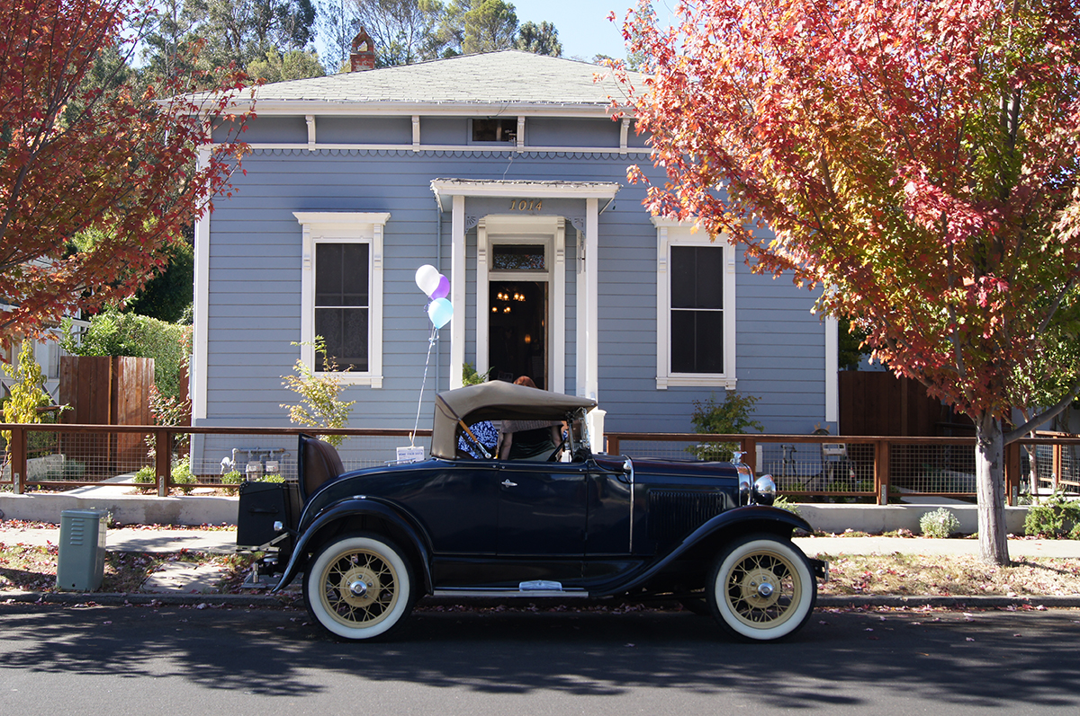

1870’s Victorian on Alhambra Avenue (same house as above) – the kitchen.

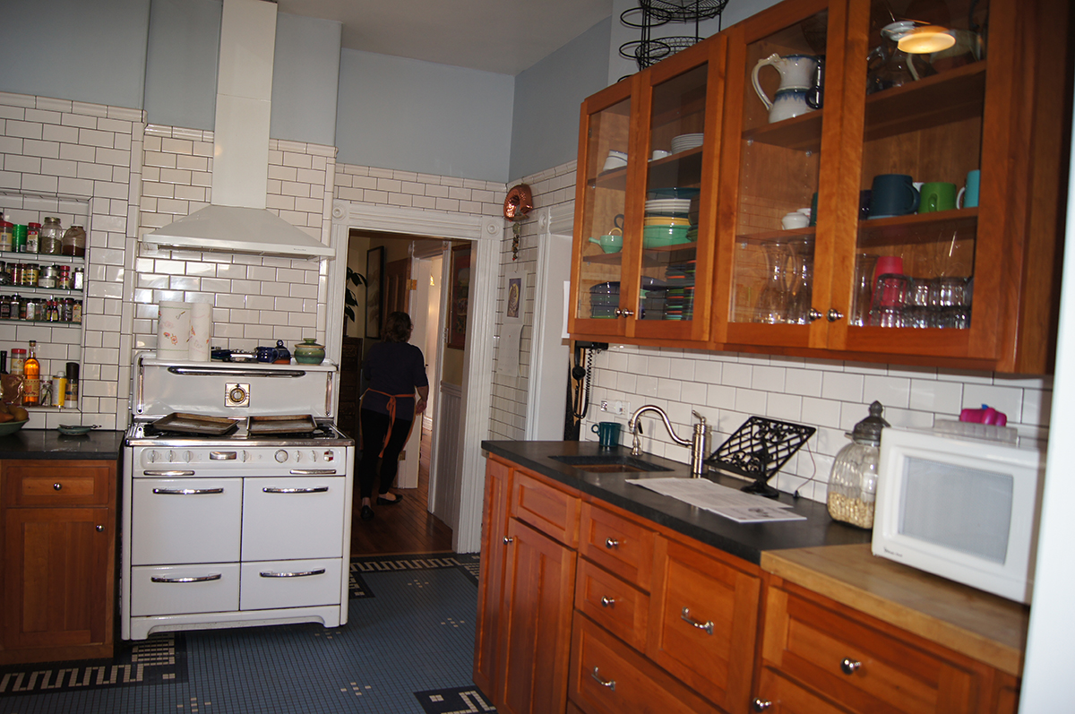

The 1877 Captain Tucker Home (on the National Historic Register) on Escobar Street.

The Front Porch The Main Stairwell

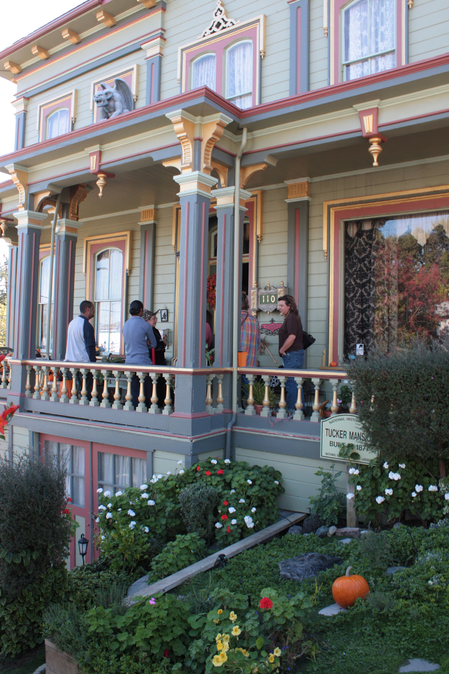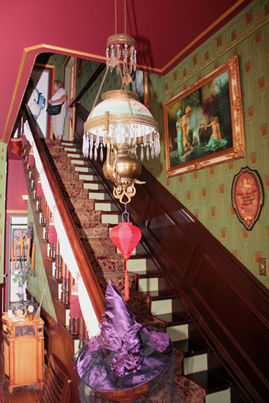

A circa 1870 Italianate Victorian on Castro Street

