PRESS RELEASE (short version)

Martinez Historical Society
PO Box 14 (1005 Escobar Street)
Martinez, California

Date: September 1, 2015

Contacts: Carolyn Boone
Email: cfboone@aol.com
Telephone: (925) 864-8457

Kevin Murray
Email: kevinmurraycan@gmail.com
Telephone: (925) 285-7526

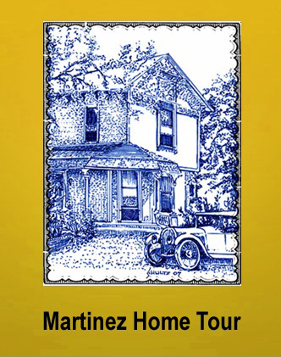

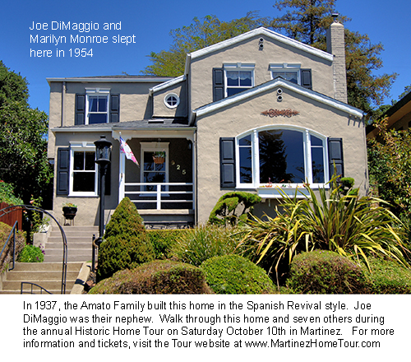

Martinez Historic Home Tour
The 9th Annual Martinez Historic Home Tour!
Saturday, Oct 10th
10am-4pm
Tickets: www.tinyurl.com/mtztour

Martinez has the largest number of classic homes in the area which makes its Historic Home Tour a popular regional event. This year, the Tour includes eight private homes, four museums and other buildings. Many of this year’s homes are in the Craftsman style which was popular in the early 1900s. Joe DiMaggio and Marilyn Monroe spent the night in one of the homes on this year’s tour. Tour goers will be able to walk through the very room where they stayed.

The Tour also includes displays of beautifully preserved and restored classic cars parked in front of the homes. It will also include live music, demonstrations and displays of historic items including a large camera collection with examples of models used by both Joe and Marilyn.

Please visit www.martinezhometour.com for the following:

- Longer press releases
- Photos of homes
- Tour details

The Martinez Historical Society is also looking for opportunities to recognize its sponsors who make the Tour possible:

• Shell Martinez Refinery  • Republic Services (Allied Waste)  • Shell Western States Federal Credit Union  • Republic Services (Allied Waste)  • Les Schwab Tires  • State Farm Insurance, Matthew Rinn, Agent  • EcoMulch | • Cole Real Estate  • Shell Chemical Company  • Hagin’s Automotive  • Bisio / Dunivan  • City of Martinez  • U.S. Bank  • Leading Edge Pest Management

