PRESS RELEASE
(Mid-length version)

Martinez Historical Society
PO Box 14 (1005 Escobar Street)
Martinez, California

Date: September 1, 2015

Contacts: Carolyn Boone
Email: cfboone@aol.com
Telephone: (925) 864-8457

Kevin Murray
Email: kevinmurraycan@gmail.com
Telephone: (925) 285-7526

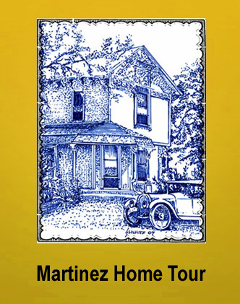

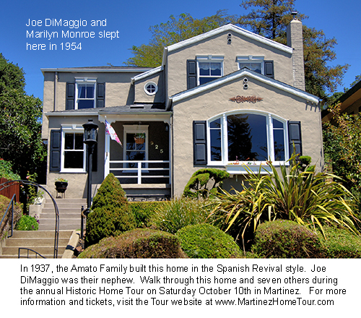

Martinez Historic Home Tour

Over the last decade, the Martinez Historical Society has worked with local home owners to present annual tours of the town’s historic homes and classic buildings. Because Martinez has the greatest number of historic homes in the area, the Tour has become a very popular regional event. Tour goers will also see a number of beautifully preserved and restored classic cars parked in front of the homes.

This year the Tour takes visitors to a special part of town. The eight featured homes are clustered in the compact area which includes only three streets: Highland Avenue, Grandview Avenue and Willow Street. This makes it possible for tour goers to have a pleasant walking experience while visiting the homes, but the Historical Society will also provide bus shuttles.

Most of the homes have not been on past tours. And many of this year’s homes were built in the popular Craftsman Style. One of the homes was built by Joe DiMaggio’s uncle in 1937. Joe and Marilyn spent the night there soon after their wedding in 1954, and a copy of their marriage license will be on display in the home.

The Tour also includes three museums which are located in historic homes: the 1849 home of Don Vicente Martinez, John Muir’s 1883 Italianate mansion, and the Borland Home, an 1890 Victorian Cottage. Also part of the day’s experience will be the 1927 Veteran’s Memorial Building, the 1937 Shell Clubhouse, and the Shell Refinery Alumni Museum.

The Tour will also include live music, demonstrations and displays of historic items both in the museums and on the Tour itself. This will include a large camera collection with photographs of both Joe and Marilyn using two of the models will be on display.

The tour is Saturday, October 10, 2015, a day to discover the treasures that make Martinez an amazingly well-preserved town right here in modern Contra Costa County. Tickets are $30 at the gate, but advance discount tickets ($25) can be purchased online at: www.tinyurl.com/mtztour

Please visit the website -- www.martinezhometour.com -- for the following items:
- Longer press releases
- Photos of homes
- Tour details

The community-minded sponsors who make the Tour possible are as follows:

• Shell Martinez Refinery  • Republic Services (Allied Waste)  • Shell Western States Federal Credit Union  • Republic Services (Allied Waste)  • Les Schwab Tires  • State Farm Insurance, Matthew Rinn, Agent  • EcoMulch | • Cole Real Estate  • Shell Chemical Company  • Hagin’s Automotive  • Bisio / Dunivan  • City of Martinez  • U.S. Bank  • Leading Edge Pest Management

