PRESS RELEASE
(Long Version)

Martinez Historical Society
PO Box 14 (1005 Escobar Street)
Martinez, California

Date: September 1, 2015

Contacts: Carolyn Boone
Email: cfboone@aol.com
Telephone: (925) 864-8457

Kevin Murray
Email: kevinmurraycan@gmail.com
Telephone: (925) 285-7526

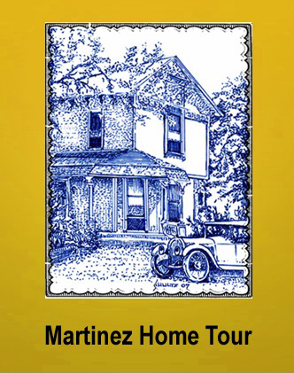

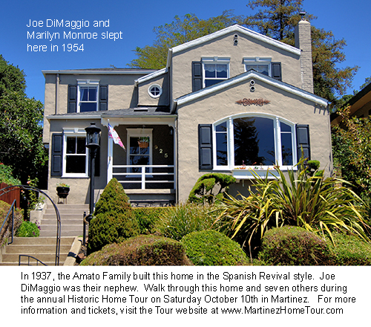

Martinez Historic Home Tour

Visitors to Martinez marvel at the rich variety of classic buildings in the downtown area and are struck by how well-kept the vintage homes are in our many downtown neighborhoods. Have you ever walked your dog down a tree-lined street and wondered what the interiors of these homes are like? Do you love history? Do you enjoy home decorating and gardening? If your answers are “yes” to any of these questions, then don’t miss the 2015 Martinez Historic Home Tour, on Saturday October 10th from 10:00 am to 4:00 pm. Tickets are on sale now at: www.tinyurl.com/mtztour

Over the last decade The Martinez Historical Society has worked with local home owners to present annual tours of our historic homes and classic buildings. Because Martinez has the greatest number of historic homes in the area, the Tour has become a very popular regional event.

This year the Tour takes visitors to a special part of town. The eight featured homes are clustered in a compact area which includes only three streets: Highland Avenue, Grandview Avenue and Willow Street. This makes it possible for Tour goers to have a pleasant walking experience while visiting the homes, but the Historical Society will also provide shuttle buses within the neighborhood and to the other locations around town.

The Tour also includes three museums which are located in historic homes: the 1849 home of Don Vicente Martinez, John Muir’s 1883 Italianate mansion, and the Borland Home, an 1890 Victorian Cottage. Also part of the day’s experience are the 1927 Veteran’s Memorial Building, the 1937 Shell Clubhouse, and the Shell Alumni Museum.

One of the best features of the Home Tour is the opportunity to meet some of the home owners who personally speak with visitors, answer questions, and share their experiences in renovating and furnishing their historic homes. In keeping with the maritime tradition of Martinez, one of our homeowner hosts is a retired Navy Captain; she and her husband are enjoying their first “permanent home” after a career on the move – “seeing the world!” Along with her home you will enjoy the art that this talented painter has created.

Homeowners from past tours have said: “I never had so much fun in my life,” or “I really enjoyed entertaining all our visitors today,” or “I love my home and love to have other people see it.” In fact, some homeowners from past years had such a great experience during the Tour that they’ve joined the Home Tour Committee and are now working to plan this year’s event.

Historically, Martinez was the commercial and political center of our county – a position it has enjoyed since its earlier origin as a Gold Rush Era seaport. Last year nearly 500 people went on the Home Tour and learned about the history of Martinez and the region while walking through the gardens and interiors of eight private homes in the Arlington Way neighborhood. This year we move across town to an area which developed in the nineteen-teens and twenties, and where our youngest home was built in 1941, just before the US entered WWII.

Last year’s visitors admired the vintage features of the homes on the tour such as dramatic columns, paneled walls and elegant crown molding. Tour goers were also intrigued by intricate cabinetry, light fixtures, and period furniture. This year will be the same, with great features like a speakeasy door and a secret room from the Prohibition Era. One of the homes was built by Joe DiMaggio’s uncle in 1937. Joe and Marilyn spent the night there soon after their wedding in 1954, and a copy of their marriage license will be on display in the home.

At the dawn of the 20th Century, Martinez had been a prosperous town fueled by river-trade and its position as a shipping conduit for grain, produce, coal, and lumber. Then exponential growth came with the oil boom in the nineteen-teens when several refineries came to town including the giant Shell Refinery which opened in 1915. Then World War I and the Roaring 20s continued to fuel growth up into the early 1930s. In the early 1930s, the new Southern Pacific train bridge over Carquinez Strait brought most Bay Area rail traffic through Martinez. The town was booming!

As cars grew in popularity, Martinez flourished with the demand for oil, and it became the portal to the north via the Martinez-Benicia Ferry. Classic cars are a big part of our home tour. We try to feature a car or two at every home on the tour and at the Shell Clubhouse. We select cars representative of the age of the homes, and typically include cars preserved in vintage condition. This adds a car show dimension to the Historic Home Tour.

Two factors distinguish this year’s homes from those in neighborhoods on recent year’s tours: new money from oil and industry, along with a revolutionary design philosophy, the Arts & Crafts Movement. This movement gave birth to Craftsmen Architecture which is featured on this year’s Tour. Three of our homes were built in the nineteen teens, two during WWI, three during Prohibition, and two during the Great Depression. Most would be considered Craftsman designs and all show significant influences which can be traced to the Arts & Crafts Movement.

As with the homes on past tours, there will be vintage features to admire such as period cabinetry, arches, tilework, antique appliances and museum-quality furniture and decorations. Visitors will also be intrigued by newer additions to the homes that blend in so well with the old. Features range from reproduction push-button light switches, newly fabricated leaded glass cabinets, repurposed historic items, and modern touches which complement the vintage decor.

The use of color in the homes is another noteworthy feature of our tours. Many of us think of the early 20th Century in black & white, but this was a period of vibrant colors and rich textures in home design and decor. Part of the Craftsman philosophy was the use of local materials to produce handmade items while shunning the machined bric-a-brac of the Victorian Era. This brings a more rugged form of elegance to the homes on this year’s Tour, and results in the oft-repeated juxtaposition of contrasting materials and colors.

The area we will tour is on the eastern slope of the downtown area, which allows for dramatic views of the water, downtown, and the valley. Most of the homes are built-into up-sloping lots which gives them a commanding presence from the sidewalk. The homes also feature attractive gardens, impressive outdoor entertainment areas, and creative examples of landscaping with limited water. These are all wonderful opportunities for great photography (exteriors only) by tour goers, and artistic inspiration.

Among the special features will be original blueprints of the 1941 Cape Cod revival home on the Tour, a classic Wedge wood stove, a hidden room behind a moving book case, a laundry chute, and a carrousel horse. One of our homes displays a mural painted by the current owner, another has original wall paper from the 1930s, and another has a chair upholstered with a chenille bedspread. Among the features to be seen in the homes will be claw foot tubs, stained glass windows, old sewing machines, and a doll from the 1890s.

A local camera collector will have a large display of antique and classic cameras at the start of the tour and each home will feature one or more cameras which suits the era in which the home was constructed. We even have a 1930s Zeiss-Contax camera with telephoto lens, identical to that once used by the town’s favorite favorite-son, Joe DiMaggio, along with a photo of Joe holding the camera. And we have a photo of Norma Jean Baker (later Marilyn Monroe) holding an early 1940s Kodak, along with an example of that camera.

There are still many opportunities to volunteer for this year’s tour on the day of the event -- as docents and ticket takers. To volunteer, contact the Historical Society through our tour website: www.MartinezHomeTour.com where tickets are also available. There are also many great pictures there of the homes and also from past tours.

It has become a tradition to include one public building on each Home Tour, and this year we will be visiting the Veterans Memorial Building. This beautiful brick building, at the corner of Ward and Court Streets, was dedicated in 1927. It had the town's first swimming pool in the basement. The pool is still there -- under the present basement floor. The recently restored building is the home of Veterans of Foreign Wars Post 1351.

The Shell Clubhouse, also part of the tour, looks today much as it did when built in 1937. Inside it retains its beautiful Craftsman interior. The Clubhouse will be the starting and ending point for the Tour. There is lots of parking in front, and it is from this point that the shuttle buses depart to convey tour goers to the private homes and other buildings on the tour. Complementary beverages will be served at the Clubhouse, and restrooms are open to our guests. Live music, booths and demonstrations can also be seen at the Clubhouse and other locations on the Tour.

Our tour is Saturday, October 10, 2015, a day to discover the treasures that make Martinez an amazing small town with its well-preserved homes and other buildings – located right here in modern Contra Costa County. Tickets are $30 at the event, or advance discount tickets ($25) can be purchased online at: www.tinyurl.com/mtztour through links at: www.MartinezHomeTour.com or from the following merchants (cash or check only):

I’ve Been Framed (411 Ferry Street)
Char’s Flowers (635 Main Street)
Martinez Museum (Court & Escobar Street)
Rumain’s Jewelry (510 Center Avenue)
The UPS Store (the Lucky Shopping Center).

NOTE: this list seems incomplete ………………………………………………….

The following sponsors make our Tour possible:

Shell Martinez Refinery
Cole Real Estate
Shell Chemical Company
Republic Services
Shell Western States Federal Credit Union
Hagin’s Automotive
Bisio / Dunivan
State Farm Insurance, Matthew Rinn, Agent
Les Schwab
EcoMulch
Community Focus
City of Martinez
U.S. Bank
Leading Edge Pest Management

See examples of photos attached. These photos – and many more -- can be downloaded from the website: www.MartinezHomeTour.com

